The 2nd Renjuclass Tournament – A Great Success

The 2nd online renjuclass tournament was finished finally after 118 ‘hard’ but exciting days. Despite the netfirms sever problems, the tournament is a great success with good participation, toughest games and great fighting spirit! The winner of the tournament cannot be determined until the end of the last game! The top three players won the same points, and the places can only be determined by Berger coefficients. This kept the suspense and tension until the very last minute of the tournament. Everybody was so excited to follow and observe the games and tournament table.

Introduction

This is the 2nd tournament of the online renjuclass. Students expected it long time ago. To avoid the email problems occurred in the 1st tournament, Volodymyr and Ando spent a lot of time and effort to build the game server that is especially suitable for the tournament. It has specially customized graphic interface, and automated clocks for counting players time. It provides the full function of Richard’s PBeM (Play-By-Email) server, but with more convenient interfaces. Players with PBeM experience can feel the great advantage of this system. Now the game server is under http://www.renjuclass.com which is open to all renjuclass students whose credit points are above 0. Guests can also come to observe games there.
The tournament was started on October 1st, 2001, and ended on January 28th, 2002. Totally 118 days. All the tournament games were played according to RIF rules, with a time limit of 40 days for each player in each game. The player has a right to use any renju books, databases, magazine, articles or any other passive forms of renju material. But he/she must not ask any other players for help, or analyse his/her games with other people. And he/she must not use any renju programs to analyse his/her games.
The tournament has 20 rounds. Each player opens 10 games and joins 10 games.

Same as the 1st renjuclass tournament, all the games of the 2nd tournament will be counted by RIF to calculate Email Ratings of world players. A lot of students will begin their renju career from this tournament.
Besides RIF Email ratings, all players also obtained great tournament experience and learned fighting spirit. This will benefit our future development of renju career.

Tournament results

The top three places were won by the following players:

1. Chengmin Sun, China (student ID: scm2000) - 18p
2. Chang-hoon Kim, Korea (student ID: heroabro) - 18p
3. Vladimir Dvoeglazov, Russia (student ID: dvoeglaz) - 18p

Very good performance! Congratulations to them!
The other results are shown in the following tournament table. Relative information can also be found at http://www.renjuclass.com under Tournament link.

Results Table of the 2nd online Renjuclass Tournament
No | Player | Pts | Berg | Place
04 | scm2000 | 18 | 180.75 | 1
14 | heroabro | 18 | 177 | 2
26 | dvoeglaz | 18 | 153.5 | 3
23 | SergeiSita | 16 | 113.5 | 4
08 | renjunewbie | 15.5 | 159.25 | 5
37 | gauss98 | 15.5 | 120.75 | 6
18 | linas2 | 15 | 128.5 | 7
16 | tjghdejr | 15 | 118.5 | 8
34 | yyfcsd | 14.5 | 100.5 | 9
13 | moocheng | 14 | 131 | 10
01 | Bensonla | 14 | 109.5 | 11
35 | yangxuzl | 13.5 | 100.75 | 12
36 | Liuchao | 12.5 | 83.75 | 13
11 | zhangfan | 12 | 103.75 | 14
17 | fourthree | 12 | 92.75 | 15
09 | ki8 | 11.5 | 110.5 | 16
05 | luwenzhe | 11.5 | 101.5 | 17
24 | jjllt | 11 | 68.5 | 18
19 | hobbang | 10.5 | 74.5 | 19
03 | Rehnstedt | 10 | 67.5 | 20
02 | ASV777 | 9.5 | 65.25 | 21
20 | mikn1 | 9 | 44 | 22
21 | shingosu | 9 | 41 | 23
12 | shuker | 8 | 53 | 24
31 | Affine | 8 | 41.5 | 25
32 | kyama | 8 | 40 | 26
10 | atlopps | 7 | 49.25 | 27
28 | bentley | 7 | 39.5 | 28
30 | Ikon | 6 | 18 | 29
15 | concord2497 | 4 | 22.5 | 30
33 | davidkl | 4 | 14 | 31
06 | yusuke_o | 3 | 10.5 | 32
27 | aramarka | 3 | 9 | 33
29 | namic_99 | 3 | 4 | 34
07 | pantrike | 2.5 | 24.75 | 35
25 | Beckham_Tang | 1 | 0 | 36
22 | sakura | 0 | 0 | 37

Facts of the tournament in numbers

- 37 (over 1/3 of the total number of registered students) players joined the tournament. Among them, 9 joined the 1st renjuclass tournament. They are: atlopps, ki8, luwenzhe, SergeiSita, concord2497, Affine, Volodymyr, ASV777, and namic_99.
- The tournament has 20 rounds. Each player opens 10 gamesn and joins 10 games.
- Every player has 40 days of think time in each game. It’s adjusted latterly because of the server problem.
- Totally 310 games were formally played (I call a game formal if it’s started before deadline and contains more than 5 moves). Among them, 156 were won by black, 136 were won by white, and only 18 were ended with a draw. The ratio of black winning to white one is 53%:47%.
- The winner of the tournament earned 18 points out of 20. A really great score!
- Totally 19 different openings were played, they are: D1, D3, D5, D6, D7, D8, D9, D11, D12, and I1, I2, I3, I4, I5, I6, I8, I9, I10, I11. The three mostly played openings are D3 (122 games), D11 (68 games), and D8 (37 games).
- The shortest game contains only 9 moves, while the longest one contains 107!

Stories of fighting spirit

Besides renju techniques and tournament experience, what we learned a lot is the fighting spirit. The story began from the following game: the white player offered a draw at 58th move because he thought he couldn’t find a win though white has great advantage. And he wanted to save time and energy for other games.
It may be true that black can defend with correct moves. But what is important is that black also has a great chance to make mistakes, and white should fight to the end until there is obviously no chance to win. In fact a lot of WC games were won by opponents’ mistakes. The players who have greater fighting spirit win more games!
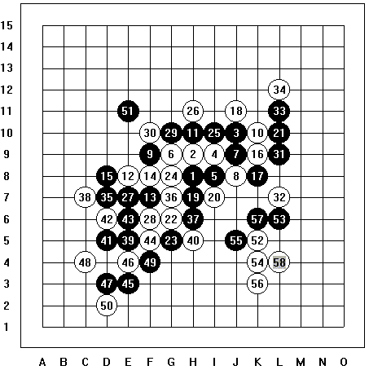

Here are some examples of fighting spirit in this tournament.
The first one is the game between heroabro and ki8. This is the last game of heroabro. He would have won the champion title if he could make a draw in this game. And the games walked toward a draw indeed. But his opponent ki8 didn’t stop fighting, and he got the chance finally! 97(?), heroabro made a careless mistake. Black was trapped double four by 98. This mistake costs heroabro’s champion title.
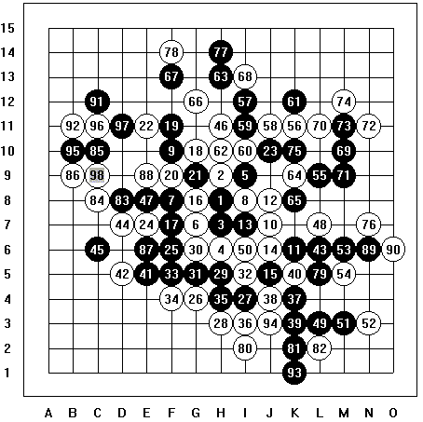
Game no230
Black: heroabro
White: ki8
The game began: Mon Oct 1 04:36:50 2001
The game ended: Sun Jan 27 22:19:03 2002

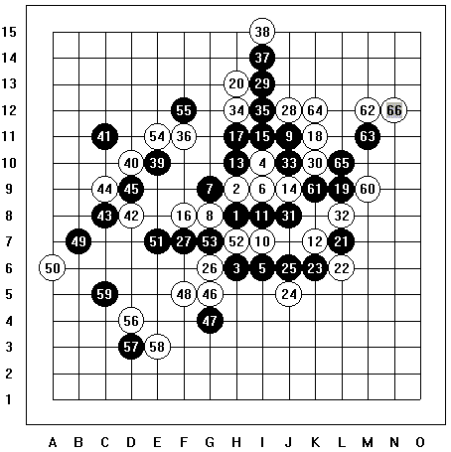
Here is another example. Coincidently, it also happened on a player who would have won the tournament. It is the last game in this tournament, dvoeglaz needed 0.5 point to be the 1st place. The time was limited for both players. dvoeglaz offered a draw at about 40 moves. After a long tournament, everybody was tired and wanted to finish the games soon. But fourthree refused the offer and continued fighting. Again, his fighting spirit rewarded him: 63(?), 64(!). dvoeglaz lost this game and the title.

Game no60
Black: dvoeglaz
White: fourthree
The game began: Mon Oct 1 08:10:03 2001
The game ended: Mon Jan 28 16:24:55 2002

The fighting spirit of ki8 and fourthree was impressive. And the two games changed the results of the tournament. The final champion scm2000 must be very thankful to these two players for their great fighting spirit.
Unfortunately, I was also taught such a lesson by ASV777. It’s my last game. After heavy fighting, the game moved toward a draw. And I offered a draw at 65th move, hoping to finish the tournament soon. But ASV777 didn’t give up the chance. The 82nd move is to trap my double three, I didn’t think hard and blocked at 83. 84(!), good move. Black cannot escape double four. 83 should simply defend at F5. Great ASV777, thank you for teaching me the fighting spirit.

Selected games of the tournament with short comments
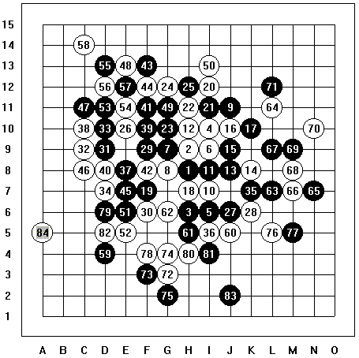

Game no160
Black: luwenzhe
White: ASV777
The game began: Sun Sep 30 16:20:38 2001
The game ended: Sun Jan 20 18:23:04 2002

  - The first normally ended game
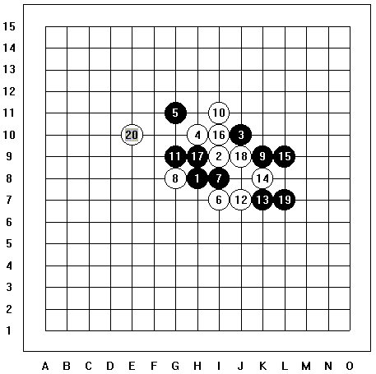

Game no18
Black: Bensonla
White: renjunewbie
The game began: Sun Sep 30 00:39:36 2001
The game ended: Mon Oct 1 01:00:26 2001

Comments:
This game took only 1 day. It was finished when other games were still at the very beginning.
Bensonla gambled 8 games on I1 opening. Unfortunately it didn’t bring him good luck. He lost 5 of them. Renjunewbie won this game with beautiful 20.

  - The lastly ended game

Game no60
Black: dvoeglaz
White: fourthree
The game began: Mon Oct 1 08:10:03 2001
The game ended: Mon Jan 28 16:24:55 2002

Comments:
This game was introduced above. It changed the tournament result: dvoeglaz lost the 1st place and scm2000 became the winner.

  - The shortest game
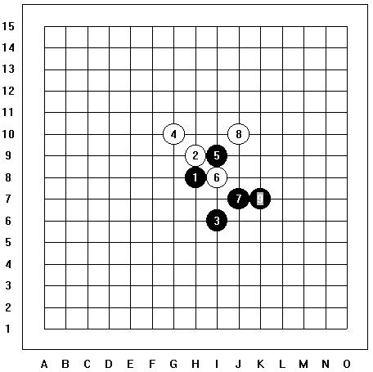

Game no379
Black: mikn1
White: shuker
The game began: Wed Oct 3 07:15:41 2001
The game ended: Fri Oct 5 01:24:45 2001

Comments:
It was an opening disaster. Some players lost similarly. It means we need to understand the openings rather than to memorize them.

  - The longest game
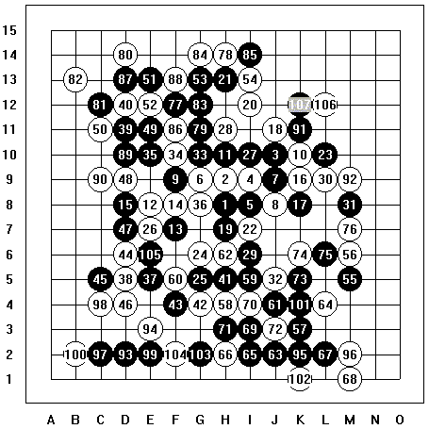

Game no184
Black: scm2000
White: zhangfan
The game began: Mon Oct 1 09:01:25 2001
The game ended: Thu Jan 24 05:37:43 2002

Comments:
A long fighting game!

  - The game between the top two players
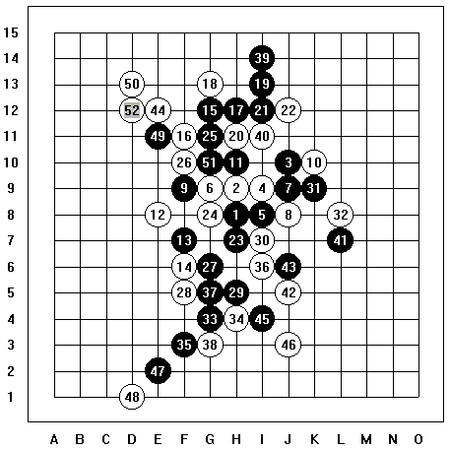

Game no187
Black: scm2000
White: heroabro
The game began: Mon Oct 1 04:36:18 2001
The game ended: Tue Dec 11 11:01:18 2001

Comments:
Due to large number of players and limited rounds, many strong players didn’t meet in the tournament. But fortunately that the best two met!
Heroabro played a weak move – 24, but scm2000 didn’t attack very well. Finally heroabro got the tempo and won the game. A good game!

There are so many beautiful games that I cannot include all of them here. Only those games with special meaning are shown here. A RenLib file that contains all of the games can be downloaded from http://www.renjuclass.com under Tournament link. Enjoy them.

Future tournaments and activities

Even before the end of the 2nd Renjuclass tournament, a lot of new students asked me when will the 3rd tournament begin and how they can join. I have every reason to believe that the future renjuclass will attract more and more good students to join. And the competition will be harder and harder.

Shortly after this exciting tournament, we will have another more exciting activity in renjuclass – the War of Roses. The whole class will be divided into two teams, one for the Red Rose, and the other for White Rose. A special game server will be setup on which the two teams can play on one board. When it is one team's turn to move, all the warriors of that team must make their vote for the next move. The system will automatically select the most voted move in the moment the deadline passes, and submits it to the big board. I believe this game will attract a lot of students.

The Renju Tournament via Email 2002 has already begun. Some of our students joined it. V. Dvoeglazov (dvoeglaz) will play in final (group A). Artemiev Sergey (ASV777) will play in semi-final (group B). And a lot of students will play in quarter-final, they are Shoude Chen (yyfcsd, group E), Haolin Yang (yangxuzl, group E), Cheng Mu (moocheng, group F), Chao Liu (Liuchao, group F), Jianxin Zhao (gumingzhao, group F), Chuangcheng Li (renjunewbie, group G), Wenzhe Lu (luwenzhe, group G), Eggert Ester (pantrike, group H), Gang Hong (fourthree, group H), Chengmin Sun (scm2000, group H), Taimla Tunnet (tunnet99, group I), Huasheng Feng (gauss98, group I), Xuan Zhou (span, group I). Good luck to all of them.

To end this article, I’d like to thank our great teacher – Ando Meritee. He spent days and nights to make the renjuclass a perfect home for renju fans all over the world. Also I’d like to thank those who helped a lot during this tournament: the technical upporters Volodymyr and farmer (great game sever!), the referees ladykayak, luwenzhe and heroabro, tournament table manager ki8 (excellent job!), and all the players in the tournament! Let’s meet in the 3rd tournaments!

