Karepa Open '99
By Ants Soosyrv
The biggest minus of this year's Karepa camp was a relatively weak tournament. There were no participants from Russia and only Stefan Karlsson from Sweden. Of course, it was great that Marko Pellikka from Finland played his first tournament with renju rules. He didn't get any points, but he undoubtedly received valuable experience. We held some blitz tournaments also and Marko performed quite well.
This time there was a rather peculiar time control on the main tournament, only 30 minutes per game. The time control was mainly conditioned by the wonderful weather, no one wanted to sit behind the board for long. The weather was probably warm and sunny all around Europe, but it's definitely not so pleasant to have a holiday somewhere else than at Karepa. So, dear readers, make your conclusions and hurry to Karepa next year!
Ando Meritee didn't have a problem with winning all of the games. His predominance was actually a lot bigger than the formal lead of one point over Stefan. Ando subdued his 8 opponents firmly, when Stefan at the same time had losses with couple of moves against Johann, Pavel and Ants. Johann and Pavel let themselves to be disturbed by the relative lack of time and Ants was just stupid. He was lucky to get the third place. In the game against Evelyn he had a worse position, but the girl was probably scared of the opponent's lack of time. She moved quickly and lost. In conclusion, two of Ando's games.
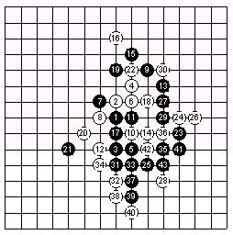
Meritee-Karlsson, 1-0, 43, D11, R
D11 has undoubtedly been the most changed opening during the last year. Before the WC of 1997 the evaluation of the position was a little bit better for white. After that, thanks to Sagara's innovations, black had complete predominance. Then the Russians had the floor by bringing the 14th move into the game. And when the Japanese, but especially the Swedes repeated themselves, then the Russians took a step forward and found the extension 17(!), 19(!), which at the moment (I'm writing this before the WC) is a serious challenge for white. Stefan decided to take up the point 20, which is really essential for black and then made one of the typical moves lately 22-22, but after 23(!) and 25(!) it's more than worse for white. And the stone black got on the 21st move gives the necessary connection to the left wing. But it wasn't needed in this game, after 27(!) I couldn't find a defence for white. Stefan also tried, but as the result shows, unsuccessfully.
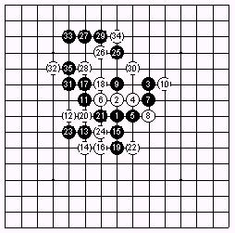
Meritee-Soosõrv, 1-0, 35, D3
15(?) - turned out to be an interesting move and it was especially difficult to react to it in a game with a short time control. I can't give an exact evaluation even now. 20(!) lets black to attack and Ando used this opportunity brilliantly. 20-24 would have given a more complicated position. Black has some resources, but white has a troublesome pair. So Ando and me didn't really understand what would happen it that position.

