Selected Games of The World Championship
By Norihiko Kawamura (ex - World Champion), 1997

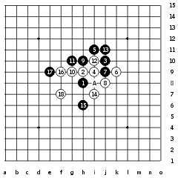
Kozhin - Meritee, 0:1
Kawamura comments: You know that this situation is famous for the game between Mr. Nakamura and Mr. Tomimori at the Meijinsen Final more than 10 years ago. I remember the comment that the situation until 9 was bad because 10th move led to win for white. Although 11 and 13 was gambling, white could beat black easily by 14,16,18.
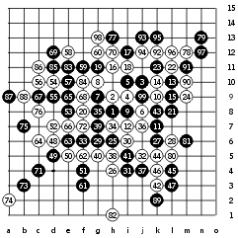
Karlsson - Hasegawa, 1/2:1/2
Kawamura comments: I don’t know 16-16 is better than 16-21. Recently lots of people seems to like it. But if it is possible for white to move 20, I believe this 16 is better. Because 16th point is the vital point for both side.
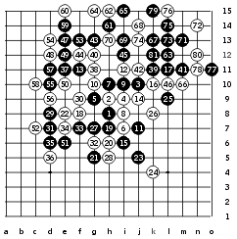
Sinyov - Soosõrv, 1:0
Kawamura comments: I have played until 18th in the Meijinsen-Final against Mr. Nakamura. At that time he played 19-28. I think 19 is not good but possible. 22nd move was very offensive and usually leads to win. But black changed the style. It was wise. I admire black’s move from 21. Black tried to surround outside. Finally, black could win. Great job!
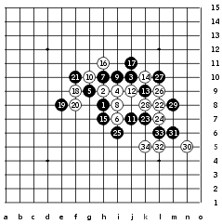
Reims - Meritee, 0:1
Kawamura comments: I think 13 was not good. Because 16 was good and black had to fear double three and be limited black move. In addition, 23 was doubtful move. I don’t know what it meant. Black seemed not to notice double three.
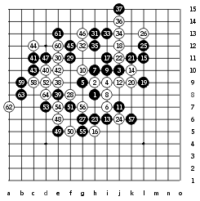
Kawamura - Meritee, 0:1
Kawamura comments: I thought 12 was not so strong. Still now, I believe 12-20 is the best instead of 12-12. But I also admit the important thing for real game is tactics. As I met this 12th move for the first time, his tactics was quite successful. I think black’s way until 23 was good enough for black. To tell the truth, 24 was lost move. White should have played 24-57. Black could win directly from 25. I found the victory the next morning! It was too late. After 27, white was not so good because white should play 57 first, but black didn’t have the chance to move 57 firster than white.
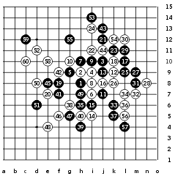
Sinyov - Reims, 0:1
Kawamura comments: I agree 13-13 is the best move for black. And I must agree 14,16 is the strongest protection. Black’s attack from 19 was gambling but failed. White’s protection was perfect. It is said that 19-one point right of 11 is better, but I think if so, black has a disadvantage.
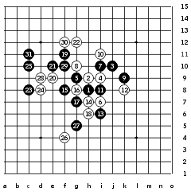
Sagara - Meritee, 1:0
Kawamura comments: When I saw the situation until 13, I thought white surely won. I think 14-15 would be better. How about 22-28? Anyway, white seemed to fear something of black. Japanese players think this game was the most "surprise". Of course Mr. Sagara is one of the best attacking players.
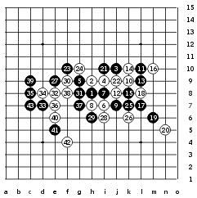
Meritee - Klimashin, 1:0
Kawamura comments: 7th move is going to spread more, I guess. 8th move is one of the strongest protection. 9,11,13 was the best moves for black. Although 14th move was strong, it gave black the chance to attack. I wonder 21-26 would be possible instead of 21-21? I guess probably black hesitated to attack strictly. Of course 23 was a good move, but I believe white must have protected. I think 36 was weak. How about 36-40 instead of 36-36?
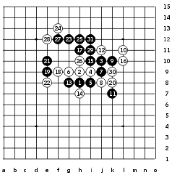
Sinyov - Nara, 1:0
Kawamura comments: This game had the relation of the game, Kozhin-Sagara. Everyone believed not to win by 14th move because Mr.Kozhin who is the author of this situation could not win by this 14. Mr.Nara also believed 14 was the best move. But, black could win very easy. Mr. Sinyov has to share the victory with Mr. Kohzin!
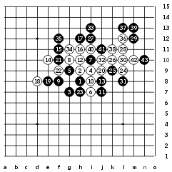
Sinyov - Klimashin, 1:0
Kawamura comments: You know this 19th move comes from Mr. Nakamura. He showed this move but only a few people followed. I think because it is too difficult to analyze. 20th move seemed to be natural, however, I don’t think it was good as a result. How about 20-21 and one point under 14 (making three) instead of 20-20? 23rd move was very strong. It worked both defence and offence. Attacking from 24 was not attractive , I mean impossible. Black could win by only stopping black.
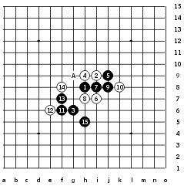
Nara - Meritee, 1:0
Kawamura comments: This game had a funny story. We (Nara and I) tried to find the victory from 15 because lots of player played thin pattern in the QT. But we could not find any victory. One day, in the morning, I found this 15th move and told all Japanese players. Nara and I checked how to win from 15 many times. As a result, we were all ready for this situation. But we didn’t think Ando selected this pattern. When I saw his move, I was sure Nara won. Moreover, I wonder why Ando didn’t find this move.
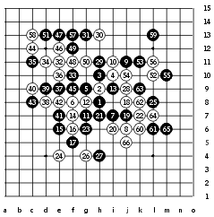
Gardström - Kawamura, 0:1
Kawamura comments: This game was the most impressive game for me. Because I played D1 in the first time at such a big tournament. Besides, It was a quite successful. Recently, I was analyzing D1 which was said not to find surely victory. I mean, 4th move is much stronger than 4-one point right of 1st move by the difference to the edge. If 13-14 then 15-13, white can stop the black. I think black can’t win by this 4th move. Now I am planning to find the victory by another 5th move.
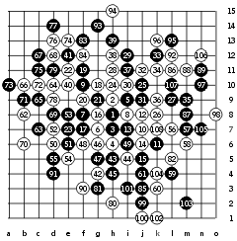
Karlsson - Meritee, 0:1
Kawamura comments: This game showed Ando’s strong and terrific attacking. I was watching this game from the middle. The situation until 39th move was desperate for both side, I believe. But he tried to trick and showed a deep attachment. I admire white had the obvious aim, double four. 90th move was one of the preparation. 92nd move was a clever timing. At last black made the lost move, 95, but I must say Stefan was not bad but Ando was good.
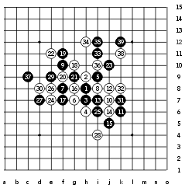
Kawamura - Sagara, 1/2:1/2
Kawamura comments: I heard this 23rd move was played by Mr. Nakamura recently. Besides, I experienced this move against Mr. Reims in the E-mail WC. But I don’t have much analysis. I believe 30th move was absolutely passive. I felt I had the chance to win. But 31 was too bad. If there was not moved 31, I would win very easy. By 32nd move, black suffered hard protection for white. I think 30-34. Though there was strict attack for black in the upper side, I gave up and accepted draw.
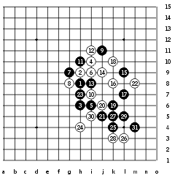
Hasegawa - Soosõrv, 1:0
Kawamura comments: I must say one important thing of this game. Black can not win from 19! If 20 moved four (4,2,8 line) and then moved one point under 17, black could not win directly, I think. I mean, the fear of double four makes black annoying. Please confirm it because it is important. So I think 14,16,18 was good way.
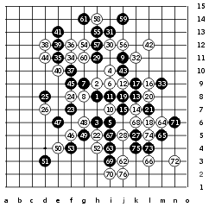
Sagara - Hasegawa, 0:1
Kawamura comments: It seems better 13-14 instead of 13-13 like some other games. The situation until 24 was very hard to win for black. And black was difficult to make game from 25. Mr. Hasegawa mentioned 29 was not good because black had to move 33. White attacked from 34, but didn’t show a surely victory. White changed the attacking place here and there. Finally, black made a mistake. That’s 67. If 67-69, then there was no win for white.
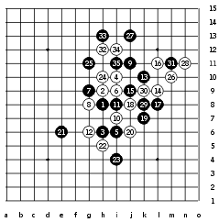
Hasegawa - Kawamura, 1:0
Kawamura comments: Now I think 14th move is not good although players believe 14 is the only move. I suggest 14-18. At that time I thought if 14-18, then black could win immediately, but it seemed impossible. The situation until 21 is very difficult for white to attack and defend. I lost very easy but I think if I played longer, I would never have won.
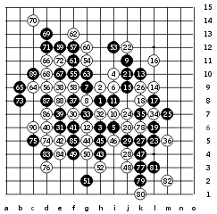
Sinyov - Sagara, 0:1
Kawamura comments: Probably all players agree black had a strong advantage until 23. As a result, black should attack more softly. For example, 21-30 or 21-27. I was surprised 30,32 could be the only protection. After that black changed the style and protected, but failed at last.

