The Renju World Championship 2001
By Igor Samotsvetov, 2001
Two years since the last, 6th Renju World Championship in Beijing (China), seemed to pass very quickly. In August, 2001 the old Japanese capital town Kyoto invited all Renju fans to take part in a great Renju festival. Everybody who could reach Kyoto believed that it would be unforgettable days of playing Renju, meeting with old and new friends all over the world, and everybody was eager and full of hope to to get acquaintance with a rich Japanese culture, traditions and a very beautiful city of Kyoto. And at least nobody was disappointed!
This time, in addition to QT (qualification to men’s final), AT (men’s final), WT (women final) and Open tournaments the organizers also forethought a Blitz tournament (12 minutes per game) with special prizes for the best and gifts to practically all players of the championship. The A-final waited for additional 5 players, which names ought to be decided in qualification. This time there were somehow no players in QT from Russia, so the chances of the other countries looked healthy. It especially can be referred to the Japanese team (Hasegawa, Nara, Kusajima, Sunagawa, Okabe) which should try its best to show the strength of the hosts.
And the battle began! After the first round Nara and Hasegawa were among the leading group and they met with each other in the 2nd round. They both seemed to be very confident and happy during this game, which lasted no more than 5 minutes – a “grossmeister” draw after the 9th move. But later the tournament ways of two surely best QT Japanese players became different. The short distance of the tournament (7 rounds) supposed no any relaxation. The next round Nara became a victim of a Korean player Kim Byoung-Jun, but had a time to recover the losses and entered AT-final tournament. This game seemed a some kind of misunderstanding. But later it became obvious that the performance of this Korean player isn’t just an accident. The last game of QT Hasegawa/black/ vs Kim Byoung-Jun/white/ turned out to be a real sensation. For Mr.Hasegawa the situation wasn’t very pleasant. Only the win could help him to reach A-final, but that didn’t frighten a young Korean player, who already beated Stefan Karlsson (3rd place of the 6th WC in China) in the previous round.
Both players were alone, excluding referee, in the quiet playing room against each other, with a board full of stones, maybe already in a time-trouble. And Hasegawa couldn’t resist the circumstances! He missed an opponent’s 4x4 threat and gave up the way to A-final to Kim Byoung-Jun. So only Hideki Nara from the Japanese team continued to fight. The Swedish team delegated two players from QT to A-final: Petter Gardström and Stefan Karlsson. I think it was expected. But what was not expected- the performance of another young player Lin Shieng-Min from Taiwan, who also got right to play in AT.
The final standings of Qualification tournament:
1. Gardström /SWE/ - 5.5
2. Kim Byoung-Jun /KOR/ - 5.5
3. Karlsson /SWE/ - 5
4. Nara /JAP/ - 5
5. Lin Shieng-Min /Taiwan/ - 5
..................................
6. Heybatov /Azerbaijan/ - 4.5
7. Hasegawa /JAP/ - 4
Therefore, the A-final turned out to be slightly unpredictable, but representative – 6 countries – and rather equal by the number of the participants from each country:
Russia - 3 (Sushkov, Sinyov, Nikonov)
Sweden - 3 (Gaulitz, Gardström, Karlsson)
Japan - 2 (Ishitani, Nara)
Estonia - 2 (Meritee, Soosõrv)
Korea - 1 (Kim Byoung-Jun)
Taiwan - 1 (Lin Shieng-Min)
The organizers of the 7th World Championship prepared a very nice surprise. The beginning of AT(and WT) had been widely performed by the Japanese national TV channel NHK in the daily news.
In the 1st round the game Meritee vs Ishitani attracted a lot of attention. D11 opening was set up with a quite new 12th move. But after 13th Ishitani fell into very deep thinking. Seemes incredible, but I had a feeling he never saw such a move before the game. And 14- already loosing answer.
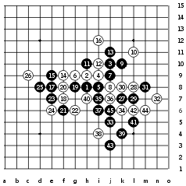 | 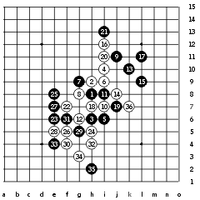
Soosõrv - Nikonov, 1:0 | Kim Byoung-Jun - Karlsson, 0:1
As you can see Stefan Karlsson got a revenge for his loss in QT.
In the 2nd round seems nobody wanted opening surprises and only standard and equal patterns of D3 were played. The games were developing very slowly, but later came the results. Both Taiwanese and Korean players lost their games to Sinyov(Rus) and Meritee(Est) by mistakes. Nikonov(Rus) got a winning advantage by black against Gaulitz(Swe). The rest of the games were played by the lack of time already. The last game between two Japanese players was outstanding. Nara, having no time at all, with the flag rising, won as black. He was lucky to find a place on the board full of stones for the final 4x3. As a result, after the 1st day Ishitani, being considered as the best Japanese in AT, got 0 points together with not so experienced Korean&Taiwanese players. Was it a sensation or a forecasted situation – we will know later.
The leaders of the first day- Karlsson, Sinyov, Meritee, Sushkov- 2 pts.
In the 3rd round the game Meritee vs Nara was in the focus of attraction. D11 was set and after 11th move Nara for a moment raised his eyes to the ceiling as if he tried to get additional help from the Japanese God, and put 12th stone on the board. He used this old move 4 times more later- against Kim Byoung-Jun, Sinyov and Karlsson. All in vain. The God seemed not to notice Nara’s calls. Only Gardström somehow lost his game to Nara with this move.
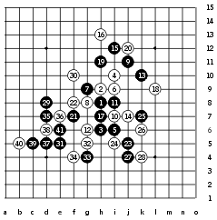
Meritee - Nara, 1:0
In the 4th round finally the working atmosphere established. No any “sightseeing” guests with cameras, only players against each other. Stefan Karlsson lost both games of the second playing day and disappeared from the leaders group. Standings: Sinyov, Meritee- 4 pts, Sushkov – 3 ½ pts, other players- 0…2 pts. So the first three created a gap of 1.5 pts already, and the people began to consider them as the real medal owners. Kim Byoung-Jun as black successfully connected flanks and won his first AT game against Nikonov. The game Lin Shieng-Min vs Nara reminded me the old RenjuClass lesson (I11 opening), where the Teacher supposed that the best plan for Black is to suppress White’s activity with 15-19. After 15-15(?) Nara confirmed that white’s attack is too dangerous.
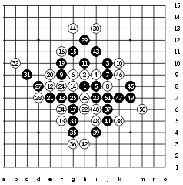 | 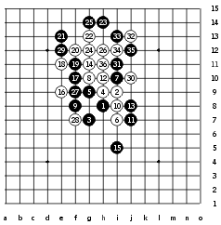
Kim Byoung-Jun – Nikonov, 1:0 | Lin Shieng-Min – Nara, 0:1
In the 5th round two best Russian players Sinyov and Sushkov played with each other. In well-known D8 opening pattern Sinyov played 14th move, which he successfully used during the Russian Highest League. But was ready against this variant. His 15th turned out to be a winning development against such 14th move. After this game Sushkov became a “temporary” leader, while Meritee still continyed to play his game with Ants Soosõrv(Est). It was the last game of the round, Meritee won and returned back his leadership. Kim Byoung-Jun once more beated Nara and it was his second win in a row!
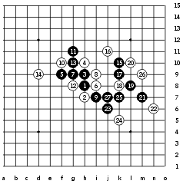
Sushkov - Sinyov, 1:0
In the 6th round the leaders won their games: Meritee vs Gaulitz, Sinyov vs Ishitani, Sushkov vs Nikonov, and the the final standings of the day didn’t change:
Meritee- 6 pts, Sushkov- 5 ½, Sinyov- 5, Gardström- 3 ½, Nara, Karlsson- 3 pts,
Nikonov, Ishitani, Kim Byoung Jun, Gaulitz, Soosõrv- 2 pts, Lin Shieng Min – 0 pts.
Still nobody could stand against Ando’s skillful and powerful attacks, and that’s why everybody considered the next day as the decisive in A-final. First game, Meritee vs Sinyov and next game, Meritee vs Sushkov – really exciting moment of the championship! Maybe it was also a chance for the other players to join the fight for the 3rd place of the tournament.
In the 7th round all Swedens lost their games and couldn’t get closer to the 3rd place. Karlsson to Nikonov, Gardström to Nara, Gaulitz to Ishitani. Meritee without any visible efforts beated Sinyov and so it became Nara’s real chance to reach for Sinyov during the next round.
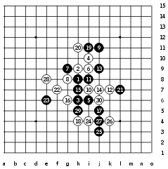
Karlsson - Nikonov, 0:1
In the 8th round it looked as if the game Meritee vs Sushkov was a battle for the 1st place and a game Sinyov vs Nara as a fight for the 3rd position. But when these games were over, nothing really changed in the tournament table. Meritee and Sinyov won and it already seemed impossible to imagine another sequence of the top three players of the A-final:
Meritee- 8 pts, Sushkov- 6 ½ , Sinyov- 6.
Other standings: Gardström- 4 ½ , Nara, Karlsson, Soosõrv-4, Kim Byoung-Jun, Nikonov, Ishitani- 3, Gaulitz- 2, Lin Shieng-Min- 0 pts.
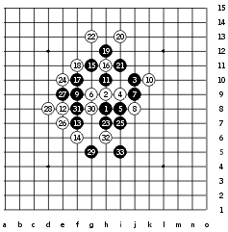
Meritee - Sushkov, 1:0
In the 9th round AT-leaders won their games (Sushkov sv Kim Byoung-Jun, Sinyov vs Soosõrv, Meritee vs Nikonov). Nara lost to Karlsson, Gardström lost to Gaulitz. By the way, Kyoto Open tournament finished, and the Japanese players showed their best, taking the first three places: 1.Hasegawa 2. Kusajima 3. Iio.
In the 10th round among the most interesting events, on my mind, was the game Sinyov vs Kim Byoung-Jun. Before this game Sinyov had a good chance to get the 2nd place, because Vladimir Sushkov played against Stefan Karlsson, and Sweden still had a theoretical possibility to take the 3rd place in the championship. And when Sinyov already lost his game, the events in the game Karlsson vs Sushkov were still at the beginning of its development. It happened to be one of the longest and greatest renju battles in the championship. Nobody wanted to give up. After the 70th move Karlsson was already in a big time-trouble(about 2 minutes till the end of a game), the referee already made a game record instead of Karlsson, and at least Sushkov used his advantage all right. So his 2nd ,”silver”,place was decided, and, by the way, he helped lucky Sinyov to get the 3rd , “bronze”, place without additional difficulties. And, of course, Ando Meritee in this round confidently became a World Champion-2001 after his winning game with Lin Shieng-Min!
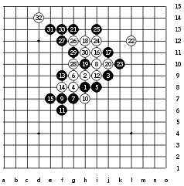
Kim Byoung-Jun – Sinyov, 1:0
30th move-white(Sinyov) made an VCF attempt to catch 4x4 foul, but… black had its own VCF! Sinyov seemed not to notice this combination, and Kim Byoung-Jun once again confirmed his talent and true fighting spirit in the most high-level tournament.
As the medals of the 7th Renju World Championship already belonged to their owners, it seemed that nothing interesting could happen in the last round of the final tournament. But it was a miracle! The intrigue of the championship still remained, because not only the first 3 places brought a glory to the players, but the first 7 places defined the number of representatives from each country in the next World Championship. And during this round Ants Soosõrv (Est) did his best to bring an additional place to his Federation in the last game of the championship against Gaulitz(Swe).
Despite all possible expectations none of the AT players thought about so-called “quick draws”(as the game Nara-Hasegawa from QT) . Moreover, there were almost no draws at all during the whole tournament! 66 hard games and only 4 draws! The fighting spirit of this championship in Kyoto seemed to be the strongest one in the history of Renju World Championships.
And what, for example, to say about the game Nara-Nikonov from the last round? Nara, as a true fighter and a host player, of course, couldn’t be satisfied with his 6th place before the game. Nikonov had a chance to fight for the 7th place. And they set an actual D11 pattern until the 12th move. 15(!!) – Nara’s home analysis. Nikonov tried hard to search for a satisfying defense plan, but couldn’t find it! After this win Nara showed possibly the best result Japanese players could achieve in WC7 – 4th place.
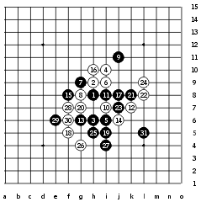
Nara-Nikonov, 1:0
The next day when the Russian delegation arrived to Tokyo, the Russian players Nikonov and Sushkov were invited to the house of the legendary Japanese Renju Master Yoshizawa, which is now over 90 years old! But Yoshizawa, the Teacher of great Shigeru Nakamura and Takashi Sagara, feels very healthy. He issues his own renju magazine, teaches Renju, and the only difference, by his own words, that now he playes renju a little bit less than ever- 5-6 hours every day instead of 10 hours in the past! And when Mr.Nikonov showed him the game record vs Nara, the Meijin for a long time deeply scanned the position and finally decided that it surely requires, on his mind, “further detailed analysis”.
The 7th World Championship is over.
Congratulations to Ando Meritee, who won the main prize very confidently without any doubt. Nobody before him, even the great Nakamura, could win ALL the games in the final tournament of the World Championship-2001. Maybe it became a surprise even to Ando himself :-))).
Nevertheless, the other players of the final also deserve the best words for their willing to show all their skill, talent and fighting spirit during the WC7. Here are the final standings of AT tournament:
1. Ando Meritee /Est/ - 11 pts 7. Stefan Karlsson /Swe/ - 5 pts
2. Vladimir Sushkov /Rus/ - 9 8. Shiniti Ishitani /Jap/ - 4.5
3. Igor Sinyov /Rus/ - 8 9. Kim Byoung-Jun /Kor/ - 4
4. Hideki Nara /Jap/ - 6 10. Konstantin Nikonov /Rus/ - 4
5. Petter Gardström /Swe/ - 5.5 11. Joachim Gaulitz /Swe/ - 3
6. Ants Soosõrv /Est/ - 5 12. Lin Shieng-Min /Tai/ - 1
Seems Ando was right when he predicted sussessful performance of Taiwanese and Korean players at WC7. Nothing else, but a real sensation became the 3rd place of Hsu Wen-Ching /Tai/ in the Women Final tournament. She grabbed this place out of the hands of strong and much more experienced Japan and Estonian women players.
The next stop is Sweden, which will hold the 8th Renju World Championship in 2003.
It seems the future belongs to the younger. Compare by yourself:
Ando Meritee, AT champion - 27 years old,
Vladimir Sushkov, AT 2nd - 22
Yulia Savrasova, WT champion - 14
Johann Lents, Blitz champion - 14
The Russians do expect the participation of the 19-year old actual European champion Alexander Klimashin. We will see.

