Team Finland in Team World Championship 2006

Estonia, Russia, Japan, China, Sweden and Finland; these countries were fighting for the title. It was quite obvious that my team would be struggling to get any points. The difference in player level and most importantly experience was so big. My hope was that we could win at least one country and I could avoid loss in at least one game. The historical first Finnish team in Renju Team World Championship consisted of the following players (in table order):

Samuli Saarenpää, Jussi Ikonen, Kari Haikonen, Marko Pellikka

The first part of my hopes became true already on Round 1 as we sensationally beat Japan 2½ - 1½! Although the Japanese team was not the favorite to win the title this year, it was still such a huge win for our young federation because the Japanese traditions in renju are so remarkable. The Japanese were expecting an easy 4-0 –victory and as Marko beat Yoshihiro Iio, the Japanese players reacted by laughing :) But shortly after this, the expressions on their faces became more and more concerned as all the 3 remaining tables showed good positions for the Finnish team. Finally, all other games ended in draw and the historical win was reality. For a short moment we were able to declare to be unbeaten in the history of Renju Team World Championships! :) This was most likely to be changed in the next round as we were to face the Estonian first team....

Despite the surprising win on Round 1, we did not have any expectations for Round 2. The Estonian first team was expected to play for gold in Finals. The result was quite expected as Estonia won 4 – 0. After this loss, we were to face Russian second team. Again, Marko managed to win as other tables faced losses so the score was 3 – 1 for Russia II.

Round 4 introduced another newcomer as we faced team China. Although newcomers, their level was clearly higher than ours and expectations were low once again :) Chinese website expected an easy 4 – 0 –victory but that’s not how it ended. I managed to win Chen Wei, who is known for his title as e-mail World Champion and Jussi gained a draw from Wu Hao, who we heard is considered as one of the top Chinese players. Overall, we managed to fight 4 – 4 against the Asian countries, which was a very good result for us.

The fifth round gave us the opportunity to play against the other gold medal candidate, Russian first team. This round ended just as expected as the Russians went to 4 – 0 –victory. We were hoping to get back to points on Round 6 as we were to meet Estonian second team. This is what happened as the final result was 2 – 2 with Marko and myself gaining wins.

Round 7 introduced the meeting of Finland and Sweden. In so many sports we are fighting hard to beat each other, but unfortunately for us we are still way behind in renju. The Swedish captain expected a 4 – 0 –victory, but luckily Marko won again his own game leaving the score to “only” 3 – 1 for the Swedish.

After the preliminary rounds, we had gained 8 points which was more than 1 point per round. I was pleased with that result, especially Marko’s performance was strong, 4 wins. We now faced 2 games against Estonia II for 7th place. The Estonians had much more spirit to fight for 7th place and they won clearly 5½ - 2½. I gained one draw and Marko won both his games.

Overall the tournament was a valuable experience to us and we had some great moments both on board and outside the playing room! :) We hope to return to this tournament next time!

My 9 games in Team World Championship 2006
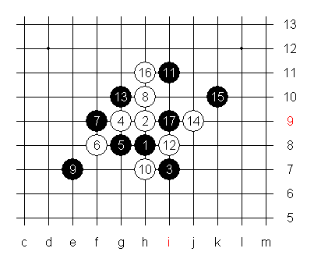
My first game was against Japanese Hiroshi Okabe. I knew very little of his playing style so I chose safely D9 expecting to get whites with the most balanced 5th move in my opinion. This is exactly what happened and I played the upper 8th move. Move 13-G10 was a surprise to me, but I was under the impression that it is weaker than the usual 13-J9. After 17-I9, I had troubles deciding my plan. I thought of 18-J10 followed by maybe 19-K8. This seemed too uncertain for me as I had not played in a long time. So, I decided to make things simple by playing 18-K8, 19-I10, and 20-J10. I was quite positive that he would not launch an aggressive attack on lower left side as I felt he was looking cautious to avoid loss at any cost. He chose 21-J7.
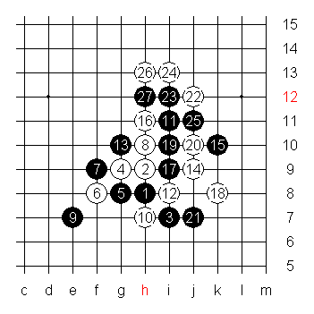

Here I had a tough decision to play 22-J12 or not. I figured if I played to lower side he would make 23-H13 and the upper side would be very secure for black. With this 22nd, black four with 23rd is needed. Continuation for white after 27th seemed tricky. Consider the black potential on right side with helpful line 23_15, say for example points L7 or J5/K5. White 28th to left side, something like E10, would be risky as the previous kind of black move on lower right side would likely force white to find VCT. And my playing form was not so strong that I could see it. This continuation is interesting however. If white doesn’t have VCT, then it can still probably defend the lower side and afterwards white has some help on top. Whereas giving the top side to black with 22nd on lower side doesn’t leave white much help there.
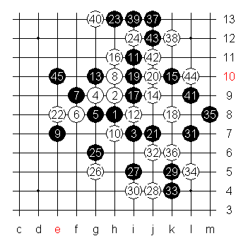
I chose 22-e8 for simplicity again and he took 23-H13 as I expected would happen. But I was still comfortable as I felt he would attack safely which would probably end up in a draw. After 44th move, the right side is dead and draw is closing. After 45-45, there was a decision to follow and try to create something on upper part or go directly to lower side like F4 or so. The lower side didn’t look too strong to win so I followed black hoping that I could get some useful stones for later attacking purposes. Perhaps here I should have played something like 46-D8 and keep the blacks unconnected but I still felt I could not get winning power without connecting lower to upper side. My moves that followed were not too strong anyway as I started to feel very comfortable with gaining a draw.

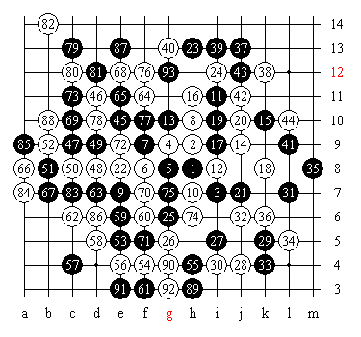
My activity was quite poor and black had no troubles in defending against my threats. After the decision to not play 22-43, I kind of gave up on the possibility to get a win which in a way practically ensured the draw but also eliminated my winning chances. Had I played more closer to the tournament, I probably would have played the other 22nd move and create white material to top and hope to defend the lower side aiming for a stronger chance of white win in the end. But for my first game in TWC, I am pleased with the draw against a player who participated in the previous WC AT.

My second opponent was no less than Ando Meritee from Estonia I. As a person very familiar to me from tournaments in Nordic countries and from his Online RenjuClass as well where I have been as a student. So, the setting was quite obvious; the teacher vs. the student. In my mind, I went through several things he has repeatedly taught in ORC and tried to feel comfortable with the fact that he likely needed only win. But still, I was not feeling too comfortable as he was to set the opening and I had no idea what was to come.

Finally, the game began with D5 opened on the board. I was surprised and immediately felt more uncomfortable as my first thought was that he has prepared something here for both colors. My own experiences from D5 were limited to only few internet games so I was on very thin ice here. I finally chose blacks as I feared he could outplay me more easily with blacks in the opening stage.
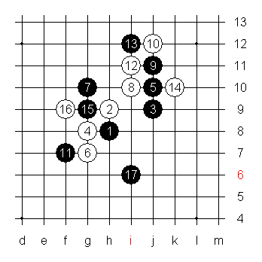
I didn’t even know the correct 5th moves against this 4th move so I offered 5-5 and 5-8. I managed to find the 7th move and found myself in an “ok” situation at move 17-17 considering how poor my knowledge of the variant was.
As far as other choices for 17th move goes, I didn’t feel comfortable making neither the four to J8/J9 or using the line 15_1 as I felt the extra moves would serve only white. With this 17th I expected white to take J7. I felt I would be able to make a small play on the lower side after this, at least safe enough to fill the area without leaving white too much material for later attacking purposes. My aim after all was to fight well and not give up the point easily even though my opponent was of totally different level in skills and experience.

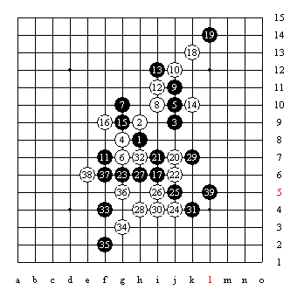
After 18-18 white took the J7 point. I felt that giving both J7 and I7 for white would be too strong so I made I7 myself. With 23-23 I hoped to keep some activity to bit more on the left side. My aim was to be able to keep lower side secure and get to make first move on the upper left side.
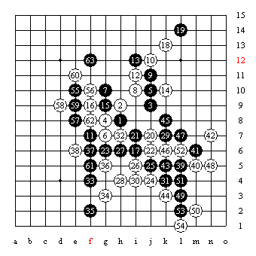
White made a series 24-30 which made an effective “wall” that separated black stones to different areas. After move 38-38 I felt that I needed to get some more balancing power from the lower right side. My first thought was 39-M5 but I feared that white could defend it in a way that left black without VCT power and at the same time kept for example point I3 very dangerous. As I was unable to find a strong continuation with safety I chose this 39th move. I felt that white would have to respond to M5 and that would give me an opportunity to kill most of white danger on lower side while keeping the tempo still.

After 40-M5 I carried out my plan to kill the area. The upper right side didn’t seem too dangerous because I had so much time left. With series 55-63 I killed most of white potential on the left side although I gave white the chance to attack against overline at F3. With the help of 31_41 I felt that the threat was not too big without more support from left side.

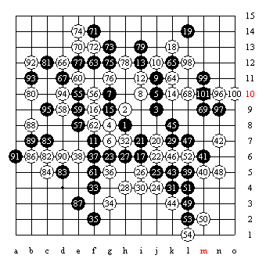
White made a strong attack on left side. Few times I was about to make a hasty move but managed to postpone my mistake. White slowly approached to overline threat but failed to make the strongest possible attack against it as black reached E3 first safely.

White’s luck in this game was that black player was me. There were not many people in the tournament that could make such a fight for 95 moves and then make the easiest mistake imaginable with 97-97! One could not blame time pressure as we both had several minutes left and each move gave 30seconds more. It is just my tendency to lose games that I absolutely shouldn’t lose after certain point. It is what makes me still a beginner.

When we stopped the clocks I was so shocked. All the people around the table felt my adrenaline during the fight after the 63rd move. As I made the final mistake I could feel the atmosphere changing. Most were kind of feeling sorry for me I guess, many were rooting for the Finnish team to get surprises in the tournament. I felt I let down my team. Even a draw against such a force as Ando is would have been most motivating for the entire team.
The game was two-sided. On one hand I was so proud of my fight against a superior opponent. But it took 2 days to be able to feel this. The disappointment after the game was so big that I couldn’t even appreciate Ando’s words after the game. The game lasted totally 4hours 45minutes, we spent almost exactly the same amount of time. The draw was in the air, maybe next time…

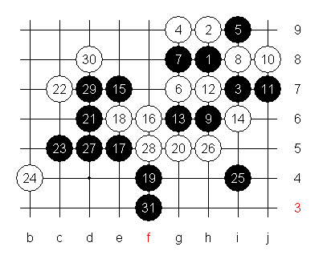
My 3rd opponent was Pavel Salnikov from Russia II. The game with Ando was still in my head and I failed get motivated to this game. I was supposed to play 12-26 but for some reason put 12-12. This was still not too bad but then 14-14 was silly as I meant to play 14-26. After this I didn’t get any control to my game and placed poor defenses and the great 25-25 finished the game. It was a shame for me to play against Pavel in this condition as I knew this is a very strong opening for him and I wanted to test myself. Normally I would choose 12-26 or at least 14-26. 12-H7 and 14-I6 together is too passive against an expert of the variant.

Round 4 promised as little as all the other rounds. I faced Chinese Chen Wei, who has been the World Champion in e-mail tournament. I had no knowledge of his playing. I got a brief preparation to current basic variants of D11 from Ando at lunch. We didn’t go too deep but his approach to our team’s interests was kind and made me feel more comfortable to playing again. As the game began with D11 indeed, I felt good about playing again and my poor mistake from Round 2 seemed to be forgotten.
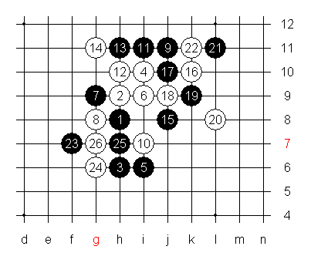
Surprising was the choice of 11th move. I was pleased because I knew he would have bigger theoretical advantage with the lower 11th move. I feel that in this variant 16-16 white doesn’t need theoretical knowledge so much and also the potential to get at least draw is big.

After 26-26 I felt the game was in good control. White has potential in two areas; say for example points F10 and L7. I heard that the Chinese were expecting an easy 4 – 0 –victory against us, but at this moment I felt that I will win more likely than black.

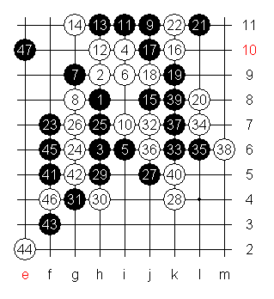
Black made an attempt to get space on lower side but I calmly stopped this. After 28-28 the power of point L7 for white became obvious. After moves 29-33 I reached this point and by 40-40 the lower right side was promising for me.

Black made good move 41-41 aiming to gain connecting power to upper left side. I felt that 42-42 is good enough and would encourage black to make the fours and move to upper side. By 47-47 I was convinced I could not lose this game and felt the necessary ambition to win. What I couldn’t really decide was to play L4+K3 right away and attack or to calmly follow black and neutralize the last area left for black and only then attack.
I felt that if he might have been expecting an easy win he might continue in a bit “sloppy” way and not take me too seriously.
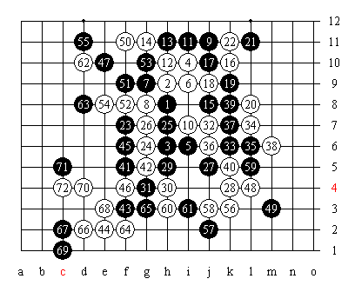
Finally I decided to play 48-48 and 50-50. I felt that I needed L4 in order to make any kind of a serious attack later on. I was not convinced I could surely play a winning sequence on top. I placed 50-50 calmly feeling he would play as he did. By 54-54 I knew I would be able to attack below soon and after 55th move it was time for K3. I made 58 and 60 aiming at F2 but for safety I played 62-62. After 64-64 white has a VCF threat, a chance to make 4x4 to N4. The simplest way to stop this would be to make own four with 65-N4 and then defend the white power on lower left side. But for some reason he played 65-65 and white win was easy. Perhaps in this game my best strength was the opposing team’s image of poor Finnish level. But the win gave my something to smile about for a change.
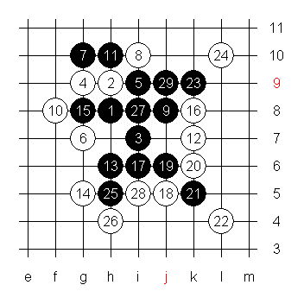
My next game was against Vladimir Sushkov from Russia I. Again I could not expect anything but I had a preparation for the game and it was 10-10. It was a shocker for him and he spent almost all his time by move 17-17. I knew this move was not very good for black. In fact, I was so pleased about this variant that I played so quickly that I forgot my own preparation. That shows again what kind of player I am…. I played 18th move too quickly as I was supposed to play 18-29 first. 18-29, 19-L7, 20-18 is a tough puzzle for black, at least with his remaining time. Should black block 19-H11 then white is able to play the left side so that black material there is useless and white gets to make F9. After that, black would be in trouble with little time left on clock and only the upper side left to use. But all this was useless knowledge for me as I played like an idiot. The funniest part is that Sushkov used the same white variant against Okabe and won. Black chose there another variant with 17th move but still. This loss was dumbest for me because had I not played so carelessly when my opponent played exactly how I hoped he would, I would have had excellent chances to beat a strong player like Sushkov. Certainly I would have had strong chances to avoid loss at least, that great was my time advantage.

My 6th opponent was Timo Ilu from Estonia II. He is more familiar to me as we have played in several tournaments. I was expecting D3 and the same variant we played some time earlier in Tampere Masters tournament in my home town. I made an easy theory mistake there in a variant I had not seen before and expected him to try it again.

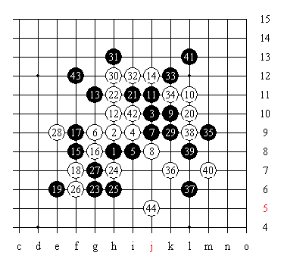
In Tampere, I made a mistake already at 12th move. This time, I knew more how to play and moves until 43-43 were expected. I didn’t have a clear idea of how to attack but 44-44 seemed logical during the game. I got the feeling he wasn’t feeling like fighting for a long game.
I don’t know what is the best defensive plan here but his choice was to take the space away with 45-K4. It seemed tough to win in this small place after that but I tried hoping he would play too quickly and make a mistake somewhere.

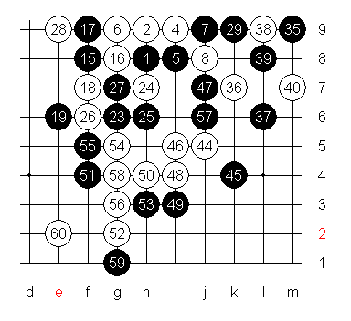
I’m still not sure how black should change the defense that Timo made. After series 46-50 white’s position seemed promising. The last mistake was 51-51 after which white has a VCT. Changing the 53rd move doesn’t help and 55-H5 would only give 3x3 to G4. The change must happen earlier already, maybe already at 45th move. Though 45-45 defends well against space, it leaves the area too open for white to use in my opinion. To say for sure would need investigating.

All in all, I was pleased of winning Timo for a change. He won the tournament in Tampere and seemed to be in strong shape before the team tournament.

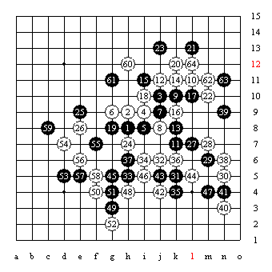
My 7th opponent was also familiar to me, Swedish Stefan Karlsson. I had managed to win both our previous meetings but was expecting that to change now. I went to the game without much enthusiasm as our team was destined to play in the Final for the 7th place. I decided to try this variant as it has been quite popular in ORC Game Server. I wanted to try something new to me and went for series 27, 29 and 31. The experiment wasn’t all bad as the lower side was quite secure but 53-53 was poor. After 54-54 white got a good help line for upper side and point F7 looked dangerous also. Final mistake 61-61 was hasty but the real question is the 53rd move. Also the chance for 39-62 came to my mind. If it would hold on the right side, then white power on upper side would diminish clearly as the helpful four lines would not be in use for later purposes. But I have not had energy to investigate this.
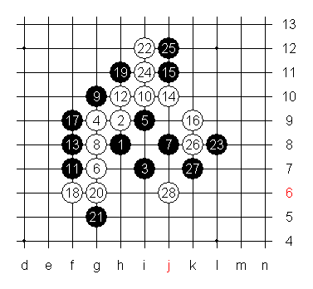
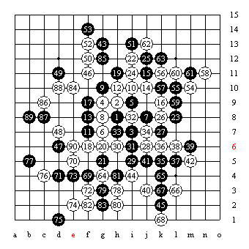
In the first game of the Final for 7th place, I opened D9 against Timo. I expected the swap and led him to this 14th move. I expected to have theoretical advantage here and it became true at move 23-23. Black power diminishes greatly as white reaches 24-I11 forcing 25-25. There is no chance to take away point K8 with 25th move as 25-K8 followed by 27-J12 would give white winning VCT making a black 3x3 to point L11. So after moves 26-28 the position seems interesting. Black power on left side is not too big since it has no connecting chances yet. Unfortunately my sharpness ended here and I didn’t reach optimal moves in the following stages.

By the 40th move, the lower side was rather neutral. After 43rd the game seemed the go only towards a draw. I made a weak attempt to gain something both on upper right side and on lower left side attacking against the overline, but not with serious threats. The draw seemed to be quite satisfying for both as neither made serious attempts anywhere or used a lot of time on any moves after the lower side was killed. I was pleased not to lose another game and Timo seemed to be pleased also to make it through another game of D9 against me without losing. At least I gained something as my choice of variant was rather successful, I just couldn’t really make a strong play afterwards.

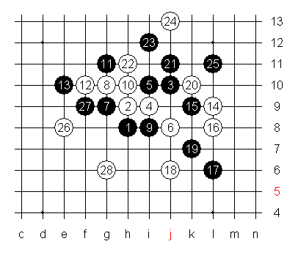
The last game with Timo brought D3 again and an expected variant too. I decided to try something weird to surprise Timo who likely knew more than me about the variant. I went for attack on lower side right away after neutralizing the upper right side with moves 20-25. I didn’t think there would be immediate chance for win but I was hoping that Timo’s fighting spirit wouldn’t be at highest levels anymore either. I expected 27-27 and 28th seemed natural. But then again my thoughts didn’t go too far ahead and Timo managed to survive easily.

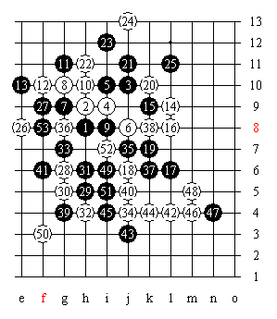
Timo made a good counter-attack with 35-35. 37-37 was strong also but 38-38 is a strong defender. The 39th move gave another chance to attack with 40-40 and 42-42 created a VCF threat which was easily to be stopped though with 43-43. Then I missed a simple counter-VCF as I played 46-46 and 48-48. I was thinking about 46-49, 47-H7 and 48-I7. That would leave white a threat that black could stop easily but it seems then white could get draw quite easily.

Overall, the tournament games went better than I expected as I hadn’t played serious games in a long time excluding the Tampere tournament. From 9 games, I managed to get 2 wins and 2 draws and from the 5 losses some games were quite good anyway. Considering the strength of all my opponents, I can be fairly pleased with my first appearance in such a tournament. Hopefully, team Finland will be soon seen playing in Renju Team World Championships again! :)

- By Samuli Saarenpää -

